**SPX COPPER PROTOTYPE CAVITY TESTING**

Stephen Bauman

Supervisors: Geoff Waldschmidt and Genfa Wu

*Abstract*

The Short-Pulse X-ray (SPX) upgrade for the APS involves placing an rf cavity in the beamline in order to ‘crab’ or tip the beam vertically, imposing a correlation between the longitudinal position of a particle within the bunch and the vertical momentum [1]. This allows it to give off x-rays with some vertical component to their trajectory, so a fan of x-rays spreads out instead of the normal tangential horizontally oriented x-ray beam. This vertically spread fan can be passed through a slit to eliminate all but a smaller portion, which cannot be done with the normal horizontal x-ray beams. This gives short x-ray pulses that can be used in cutting edge research such as battery-cell technology and photosynthesis. The crabbing process requires establishing a field resonance in the cavity that is oriented just the right way. Thus, studying and characterizing the fields in the designed crabbing cavity is very important to maintaining the stability of the beam.

Fig. 1: TM010 dipole mode in crab cavity

Fig. 2: Cross-section of crab cavity with TM010 mode

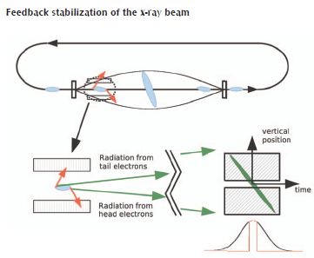

**INTRODUCTION**

Whereas accelerating rf cavities use longitudinal electric fields of the TM010 mode to propel the beam in the longitudinal direction, the crab cavity uses the on-axis TM110 mode to influence the beam vertically. A mode is just a field orientation that resonates in a cavity at a certain frequency. This cavity’s crabbing mode works by the horizontally-oriented transverse magnetic field acting as a dipole magnet in the center of the cavity. This follows from the equation for magnetic force on a moving charge.

$$\overset{⃑}{v}×\overset{⃑}{B}=\overset{⃑}{F_{B}}$$

Figs. 1 and 2 show the E and H-fields, respectively, of the working mode of the crab cavity, which resonates at 2.815 GHz. Since there are other modes resonating in the cavity that could affect the beam in an undesired manner, there must be a way to eliminate them so that only the crabbing mode is present.

**WAVEGUIDES AND DAMPERS**

Lower order modes (LOMs) and higher order modes (HOMs) in the cavity resonate at lower and higher frequencies than the working mode, respectively. Waveguides can be used to couple the undesired frequencies to propagating waveguide modes, and dampers connected at the ends of the waveguides to decay the modes.

Normally waveguides operate at the TE10 or TE20 waveguide modes. These refer to the electric field perpendicular to the broad wall of the waveguide that is transverse with respect to the direction of propagation down the waveguide.

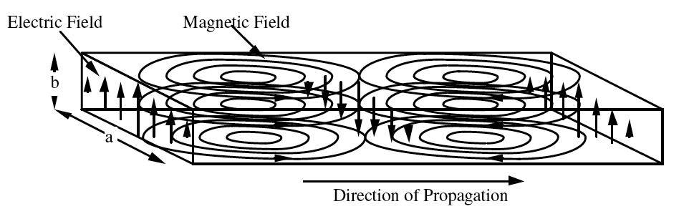

Fig. 3: Rectangular waveguide modes

These modes (Fig. 3) span half and full wavelengths along the broad wall, respectively, because the electric field parallel to the short wall of the waveguide must be zero. Thus, the TE10 mode has a peak E-field in the center and the TE20 mode has peaks on either side of the broad wall.

Cavity modes coupled to these waveguide modes can be decayed to low or no resonance by adding dampers. Fig. 4 shows this effect in a waveguide damper.

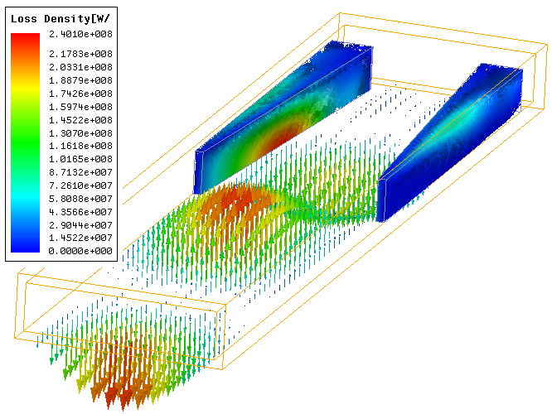

Fig. 4: TE10 mode propagation in waveguide and decay in damper

**CONCLUSIONS**

**SPX CAVITY COUPLING TO WAVEGUIDES**

An important property of waveguides is their cut-off frequency, given by [2]

 (1)

Where $a$ and $b$ correspond to rectangular waveguide width and height and $m$ and $n$ to the values describing the mode (TEmn). Any mode at or above this frequency can propagate down the waveguide, but those that are lower will not.

Fig. 3 can be used to visualize this. Clearly, any mode with a wavelength longer than the ones established in the TE10 and TE20 modes will not have zero E-field at the short walls. The cavity mode may try to couple to the waveguide mode, but it will be attenuated before travelling far through the guide. This effect allows all of the HOMs from the cavity to be eliminated by simply having HOM waveguides with a cutoff frequency of 2.88 GHz, just above the 2.815 GHz crabbing mode that is desired to resonate in the cavity.

**CRABBING MODE COUPLING TO WAVEGUIDES**

In order to eliminate the LOMs from the cavity, a waveguide cannot simply be used, as the cutoff frequency of 2.08 GHz that allows these modes to propagate will also allow the working mode to propagate since it is at a higher frequency. The crabbing mode is a dipole mode, however. This means that it will not couple to the TE10 mode in the cavity, but the TE20 mode. Figs. 5 and 6 help to visualize this coupling. The electric fields in the cavity and in the waveguide are oriented in the same way. Both have two areas of peak E-field as opposed to the single peak of a monopole mode in the cavity that couples to the TE10 mode in a waveguide.

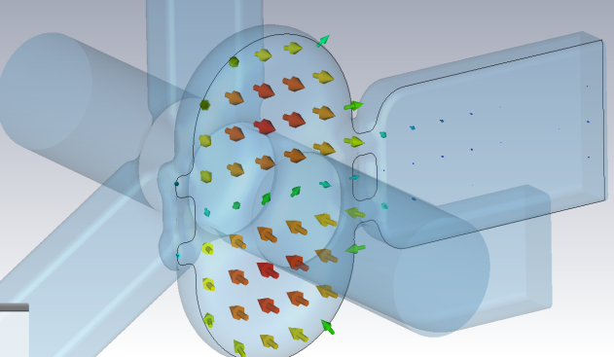

Fig. 5: TM110 working mode in cavity

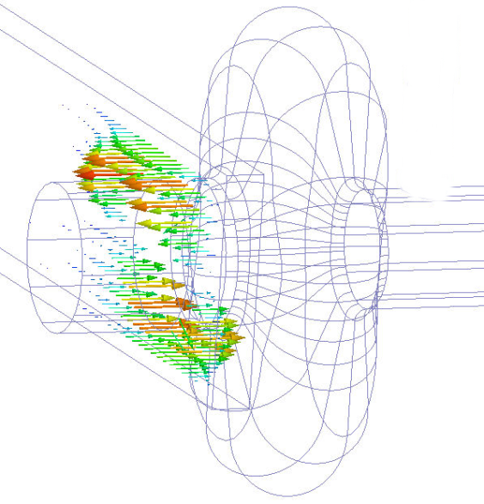

Fig. 6: Coupling to TE20 mode in LOM waveguide

The cutoff frequency for the TE20 mode is twice that for the TE10 mode in any waveguide. Since the crabbing mode couples to this TE20 mode, the waveguide has a cut-off frequency of greater than 4 GHz for this mode. The working mode is below this, and therefore cannot propagate down the waveguide nor be damped, so it continues to resonate in the cavity. This allows the lower order modes to be decayed and all that remains in the cavity to act on the beam is the crabbing mode.

**CAVITY PARAMETERS**

An important definition is the cavity Q factor. This is a measure of how much power is absorbed by the lossy metal of the cavity, as well as how much is extracted from the cavity by the dampers. It is given by,



(2)

Where $P_{c}$ is the loss of the cavity and *U* is the stored energy given by,



(3)

The Q factor is important in determining the decay rate of the energy in an rf cavity. The stored energy in the cavity produced by a pulsed input (bunch train) with an initial energy of *U0* is given by,



(4)

This shows that a bunch can dump energy into the cavity and cause a mode(s) to resonate a mode dependent on the Q factor. For modes other than the crabbing mode, the Q needs to be lowered so that they don’t resonate long enough for the next bunch to arrive and add to the resonance of the undesired mode.

Shunt impedance is a measure of how strongly the beam interacts with a cavity. It is defined as,



(5)

This value is more dependent on properties such as cavity material and temperature. If we divide the shunt impedance by the Q factor we obtain a measure of the beam/cavity interaction that is independent of the losses in the cavity,



(6)

R/Q is a convenient measure of the interaction of the beam and cavity while neglecting the precise material composition of the cavity. It is more dependent upon the geometry of the cavity. If a cavity mode interacts strongly with the beam, it is critical to damp that mode sufficiently.

**EXPERIMENTAL SETUP**

For experiments, a copper prototype of the superconducting niobium cavity was constructed. Initially, the LOM and HOM ports were covered with blanking plates. Driving and probing antennae connected to a network analyzer were able to be inserted into the cavity or ports as desired in order to measure the internal resonating modes. A nylon string was run through the cavity and around a system of pulleys connected to a stepper motor for bead-pull tests. A LabVIEW program was used to control the stepper motor and the data acquisition device (network analyzer).

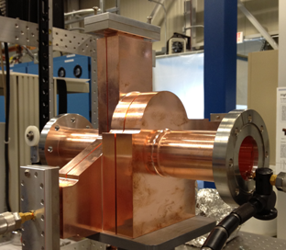

Fig. 7: Copper cavity prototype with probe inserted in beam pipe and HOM waveguide port

**DETERMINING FIELDS IN CAVITY AND WAVEGUIDES**

The network analyzer was used to find the cavity mode spectrum. The network analyzer has different ways to measure the difference between output and measured power at given frequencies. S11 is a measure of the reflected power at port one (in dB). S21 is a measure of the transmitted power from port one to port two (in dB). Resonant cavity modes appear as peaks at specific frequencies on the S21 plot.

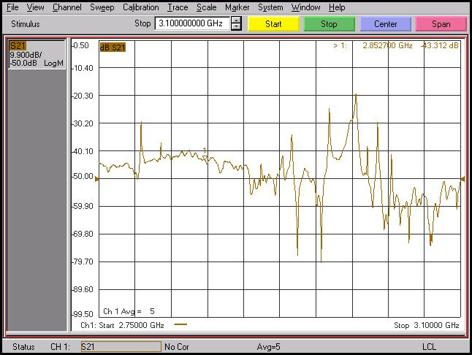

**Frequency (Hz)**

Fig. 8: The network analyzer frequency span (2.75 to 3.1 GHz) is shown. Peaks appear at frequencies where there are resonant modes.

Zooming in on a specific peak allows it to be more easily analyzed. Mode frequencies and Q values are obtained directly from the network analyzer.

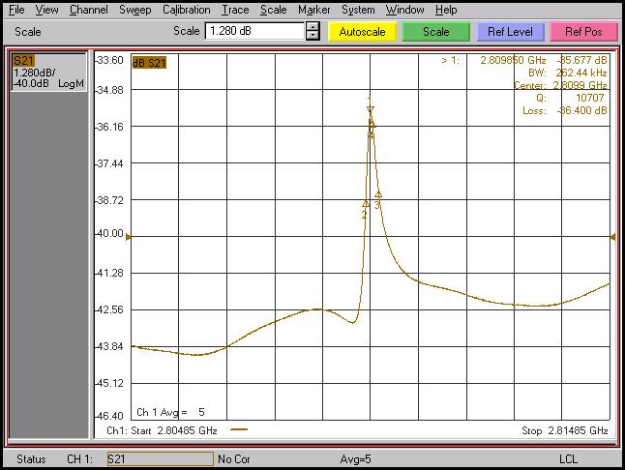

Fig. 9: 2.815 GHz working mode with Q calculated by network analyzer

**BEAD-PULL**

Fig. 10: Copper cavity beam pipe with bead and drive probe

A dielectric or metal bead is pulled through the cavity via stepper motor and nylon string on a pulley system. The bead perturbs the field in the cavity, causing a frequency shift that can be measured by the network analyzer.

Fig. 11: Frequency shift versus position for 2.98 GHz mode

The frequency shift is related to the E-field and H-field by, [3]



(7)

For a metal bead, as it interacts with both the E and H-fields. For a dielectric bead, $μ_{r}=1$, so the equation becomes,



(8)

Thus, a simple relation between the frequency shift obtained by a bead-pull test can be used to find the E-field strength profile in the cavity for a given mode.

**LabVIEW**

Bead-pull testing was automated by LabVIEW. LabVIEW is a programming language with a graphical interface that interfaces to laboratory hardware. LabVIEW performs three preliminary steps (Configures PNA, Sets-up markers, Sets-up stepper motor) before running bead-pull. LabVIEW executes a bead-pull based on frequency span, bead-pull distance, and step size. It steps the bead through the cavity and records the frequency shift at each location.

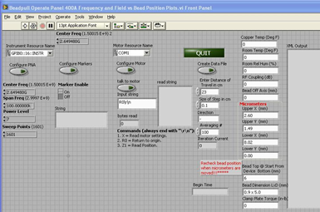

Fig. 12: LabVIEW control panel

The code was modified to perform real-time feedback of the cavity field profile.

**MICROWAVE STUDIO (MWS) AND EXPERIMENTAL RESULTS AT A HIGHER-ORDER MODE**

A bead-pull and MWS simulation were compared for the 2.98 GHz TEh cavity mode.

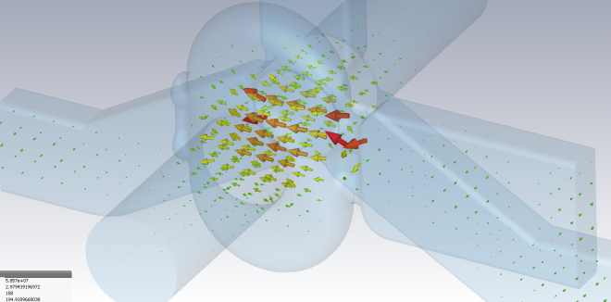

Fig. 14: E-field at 2.98 GHz

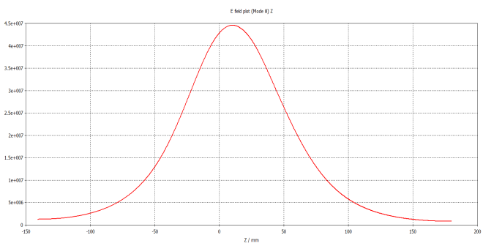

Fig. 15: E-field vs longitudinal position from MWS simulation

Q: 15.09k Freq: 2.98 GHz

Q and frequency were measured using the network analyzer and a bead-pull was performed using LabVIEW.

Q: 10.25k Freq: 2.979 GHz

Fig. 16: E-field vs longitudinal position from bead-pull test

**E-field**

Fig. 13: LabVIEW block diagram and modified code

The 3D MWS plot shows the field strength in areas of the cavity as well as the vector direction of the field. The field strength plots can be used to test if the copper cavity field strength changes longitudinally by comparing the simulated and experimental plots. The actual direction of the field cannot be determined by this simple bead-pull method, however.

From Figs. 14 and 15 it is clear that for this 2.98 GHz TEh mode, the field strength in the cavity changes with the same relative profile longitudinally.

**COMPARISON BETWEEN MWS AND EXPERIMENTAL RESULTS FOR LOMS AND HOMS**

Microwave Studio was compared with experimental results for selected LOMs and HOMs. Cavity field profiles were compared, as much as possible, with MWS results.

Fig. 17: Q vs frequency for simulated and measured values

(MWS)

The Q-factors attained via MWS tend to be higher than measured values for Q. This is largely due to the fact that the network analyzer probes load the cavity and the cavity surface has not been processed. Both reduce the measured Q.

**DAMPERS ADDED TO WAVEGUIDES**

To test the effectiveness of the damping scheme in the cavity, the waveguide arms and dampers were added to the copper prototype.

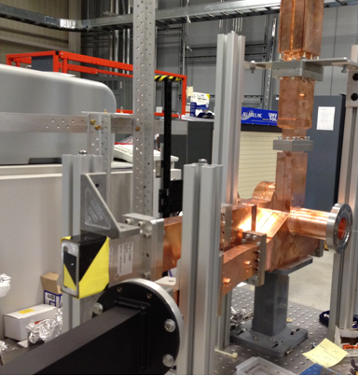

HOM Dampers

Fig. 18: Copper cavity with dampers

LOM Damper

Upon addition of the dampers, most peaks on the network analyzer were no longer visible. Aside from the working mode, any visible peaks were not as sharp as in the cavity without dampers. Fig. 19 can be compared to Fig. 8 to see this change.

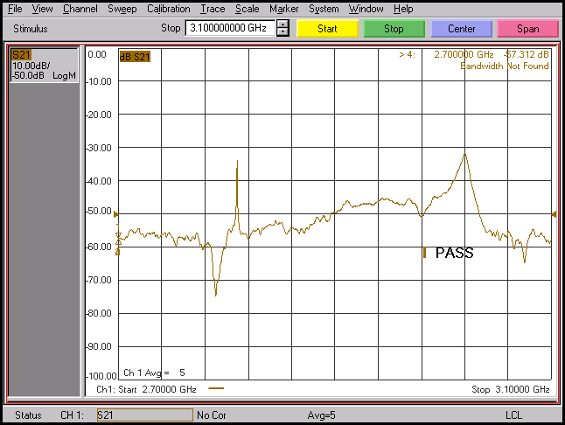

Fig. 19: Frequency span (2.7 to 3.1 GHz) with dampers on

The additional loss due to the dampers is represented by the new value of Q.



(9)

Q factors were measured for some of the modes via the network analyzer and also by MWS in order to compare them with undamped values.

|  |  |  |  |  |  |  |
| --- | --- | --- | --- | --- | --- | --- |
| **Mode Name** | **Freq (GHz)** | **Q (No Dampers)** | | **Q (Dampers)** | **Q (No Dampers)** | **Q (Dampers )** |
| TM010 | 2.151 | | 9737.4 | 13 | 9082.4 | N/A (less than 100) |
| TM010 | 2.264 | | 13,264 | 64.6 | 6579.9 | N/A (less than 100) |
| TM110 | 2.815 | | 16,316 | 15,289 | 10,707 | 17,177 |
| TEh | 2.917 | | 10,261 | 255 | 9339.8 | 183.69 |
| TEh | 2.979 | | 15,086 | 134 | 11,497 | 294.6 |
| TEv | 3.023 | | 14,815 | 1110 | 8282.5 | 586.574 |
| TEh | 3.051 | | 12,614 | 31.6 | 8298.2 | N/A (less than 100) |

The results showed that upon adding dampers to the waveguides, all of the LOM and HOM Q factors were significantly lowered. This is expected, and a sign that the modes are successfully being damped. The working mode actually has a higher measured Q because the LOM damper helps decay the coupled waveguide mode even more quickly, so the energy is more strongly resonant in the cavity.

**CONCLUSIONS AND FUTURE WORK**

The copper prototype of the superconducting niobium crabbing cavity for the short pulse x-ray upgrade was tested experimentally and simulated via Microwave Studio. The modes in the cavity were studied in order to determine how well the prototype modes correspond to the simulated modes.

The network analyzer was used to determine experimental Q values for modes and they were compared to MWS results. Bead-pulls were performed in order to model the field strength profile longitudinally in the cavity. These were also compared to MWS to help determine if the modes observed in the cavity corresponded to simulated modes.

The LabVIEW controller program was modified to make bead-pulls easier by outputting real-time plots of frequency shift.

Dampers were added to the waveguide arms of the cavity to test the damping of unwanted modes. Q values were found to decrease drastically for the modes other than the 2.815 GHz crabbing mode, showing that the cavity-damper system successfully allows only the working mode to resonate. This is the desired effect to maintain beam stability in the APS.

Future work on the project will involve more measurements and characterizations of modes in the cavity. The LabVIEW program can be further modified to use the phase shift from the network analyzer instead of the frequency shift during a bead-pull, as this may give more accurate results. Off-axis bead-pulls can be performed and used along with calculated R/Q values to try to characterize modes that may have zero E-field on-axis, and therefore do not show a frequency shift upon on-axis bead-pulls.

**ACKNOWLEDGEMENTS**

The work done at the Advanced Photon Source at Argonne National Laboratory is supported by U.S. Department of Energy Office of Science under Contract No. DE-AC02-06CH11357. I give my thanks to my mentors Geoff Waldschmidt and Genfa Wu, as they guided me along the way in my research. I hope that my contributions will be able to help with future work on the cavity and SPX upgrade. I give a special thanks to Yawei Yang, for the time taken from his own schedule to teach me, and for the confidence he gave by telling me I learned quickly. This work would have been much more time consuming without help from Tim Jonasson in setting up equipment in the lab when time was of the essence. I thank the entire Lee Teng Committee, especially Linda Spentzouris and Eric Prebys for giving me this outstanding learning opportunity. The same goes for all the people associated with the USPAS. Lastly, I thank my fellow Lee Teng interns for all the good times at USPAS and thereafter. Surviving the work load and exploring Grand Rapids was a great bonding experience for us. Very great thanks to all.

**REFERENCES**

[1] Advanced Photon Source Upgrade Conceptual Design Report, November 2010.

[2] Pozar, David M., Microwave Engineering Second Edition, John Wiley & Sons, Inc., 1998

[3]Sumit Som, Sudeshna Seth, Aditya Mandal, Surajit Ghosh, Bead-pull measurement using phase-shift technique in multi-cell elliptical cavity, Proceedings of IPAC2011 MOPC088, San Sebastián, Spain (2011).

[4] P. Goudket, C. Beard, P. McIntosh, G. Burt, A. Dexter, R.M. Jones, Comparison of stretched-wire, bead-pull and numerical impedance calculations on 3.9 GHz dipole cavities, Proceedings of EPAC08, Genoa, Italy 2008.

[5] J.C. Amato, H. Herrmann, Improved method for measuring the electric fields in microwave cavity resonators, Rev. Sci. Instrum. 56, 696 (1985); doi: 10.1063/1.1138208

[6] Discussions and emails with mentors Geoff Waldschmidt, Genfa Wu, and Yawei Yang